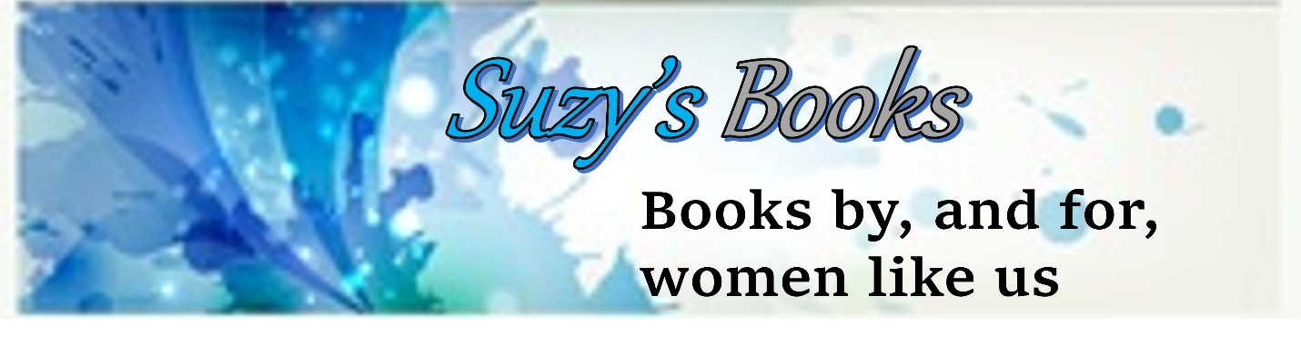
Yes! I AM INTERESTED
You may choose to fill out this form online. (Just save a copy to your computer. It will then act as your document.) Email the completed form to: maryannthewriter@aol.com .
Or you may choose to print out the form and fill it in by hand. You can then scan it into your computer and send the scanned file (as a pdf) to: maryannthewriter@aol.com .
You can also re-enter the form as a new doc on your computer, but that sounds tedious.
(maryannthewriter@aol.com is also the email if you have any questions.)

Your real name: __________________________________
Your name as you want it listed on SuzysBooks.com: _____________________________
I live in (country) __________________________________
My email is ____________________________________________________
This is how I promote my books now:

This is what I can contribute to Suzy’s Books Crew members (i.e., the promo help you can provide:

___ Posting on FaceBook
___ Posting on Instagram
___ Posting on BlueSky
___ Posting on Amazon
___ Posting on GoodReads
___ Posting on Twitter
___ Posting on (list others) ________________________________________
___ Reviewing/ beta reader
___ Blurb writing
___ Cover critique
___ Proof reading short selections
___ Writing articles to include several books
___ Promote to my own mailing list
___ Promote on my own website

Other ways I can contribute to Suzys Crew:

Check one:
_____ Yes, I have a newsletter list of (number) _______ readers.
_____ No, I do not have a newsletter list at this time.

My website is: ______________________________________________
This is the book I want to promote first: ________________________________________
This book is in the general genre of: ___________________________________________
There are several other books I would like to promote that are in the same genre, such as: (Note 2-3 titles that will sit beside yours in Category searches)

I want to become a member of Suzy’s Crew because:

Please Initial:
___ I am a female writer.
___ I do not use AI in my published works.
___ I understand that Suzysbooks.com and/or MaryAnn Shank may earn a commission when my own title(s) sell.
___ I understand there will be NO direct compensation for my contributions, or for the sale of my book(s) other than what the hosting website (like Amazon) provides.
___ I understand that this is a non-binding agreement, and that Suzysbooks.com and/or I may terminate the agreement at any time with or without a reason, and that any contributions I have made to SuzysBooks.com will remain with the copyright holder of SuzysBooks.com.

Please make any other notes you would like to add:

_________________________________ __________________________
Your signature Date

_________________________________
Please print your name
That’s it. I will email you with questions or comments, and will definitely let you know if there is a spot for you in Suzy’s Crew.

